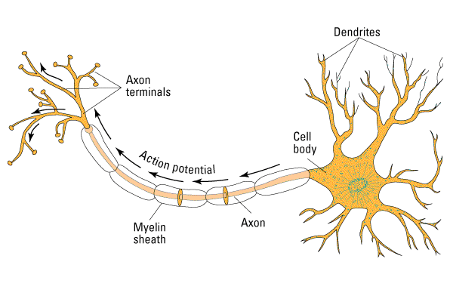

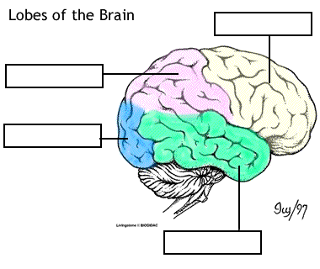

Brain Measurement:

|  |  |  |
| --- | --- | --- |
| Behavioral Measures | Good Things: | Bad Things: |
| Accuracy – how much you are getting right (percent, number of items) |  |  |
| Reaction Time – speed of processing, how fast someone does something |  |  |
| Judgments – teacher evaluations, scale, Likert (1-7) |  |  |
| Protocol Collection – ask people about a task they are doing |  |  |

|  |  |  |  |  |  |
| --- | --- | --- | --- | --- | --- |
| Correlational Measures | | Time | Space | Pain | $$ |
| EEG | Electric |  |  |  |  |
| ERP | Electric |  |  |  |  |
| EMG | Electric |  |  |  |  |
| MEG | Blood |  |  |  |  |
| PET | Blood |  |  |  |  |
| MRI/fMRI | Blood |  |  |  |  |
| Optical Imaging | Lasers |  |  |  |  |

|  |  |  |
| --- | --- | --- |
| Causal | Good Things: | Bad Things: |
| Lesions – stroke, aphasia, cancer/removed tumor |  |  |
| Drugs |  |  |
| TMS |  |  |